Quiz - Week 8: Mixed Review
- An object is thrown with a horizontal velocity of 20 m/s from a cliff that is 125 m above level ground. If air resistance is negligible, the time that the object takes to fall to the ground is most nearly
  - 3 s
  - 5 s
  - 6 s
  - 12 s
  - 25 s
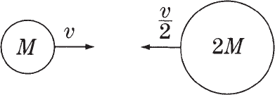
- A ball of mass M and speed v collides head-on with a ball of mass 2M and speed v/2. IF the two balls stick together, as shown above. If the two balls stick together, their speed after the collision is

  - 0

- An ideal monatomic gas is compressed while its temperature is held constant. What happens to the internal energy of the gas during this process, and why?
  - It decreases because the gas does work on its surroundings.
  - It decreases because the molecules of an ideal gas collide.
  - It does not change because the internal energy of an ideal gas depends only on its temperature.
  - It increases because work is done on the gas.
  - It increases because the molecules travel a shorter path between collisions.

- The wavelength of yellow sodium light in vacuum is 5.89 3 10–7 m. The speed of this light in glass with an index of refraction of 1.5 is most nearly
  - 4 x 10^{–7} m/s
  - 9 x 10^{–7} m/s
  - 2 x 10⁸ m/s
  - 3 x 10⁸ m/s
  - 4 x 10⁸ m/s

- A system initially consists of an electron and an incident photon. The electron and the photon collide, and afterward the system consists of the electron and a scattered photon. The electron gains kinetic energy as a result of this collision. Compared with the incident photon, the scattered photon has
  - the same energy
  - a smaller speed
  - a larger speed
  - a smaller frequency
  - a larger frequency
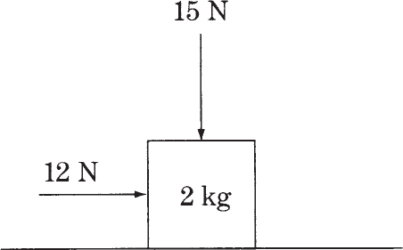
- A block of mass 2 kg slides along a horizontal tabletop. A horizontal applied force of 12 N and a vertical applied force of 15 N act on the block, as shown above. If the coefficient of kinetic friction between the block and the table is 0.2, the frictional force exerted on the block is most nearly
  - 1N
  - 3N
  - 4N
  - 5N
  - 7N
- When ¹⁰B is bombarded by neutrons, a neutron can be absorbed and an alpha particle (⁴He²⁺) emitted. The kinetic energy of the reaction products is equal to the
  - kinetic energy of the incident neutron
  - total energy of the incident neutron
  - energy equivalent of the mass decrease in the reaction
  - energy equivalent of the mass decrease in the reaction, minus the kinetic energy of the incident neutron
  - energy equivalent of the mass decrease in the reaction, plus the kinetic energy of the incident neutron

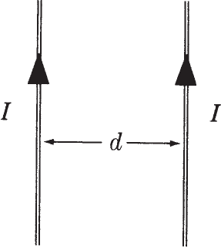
- Two long parallel wires, separated by a distance d, carry equal currents I toward the top of the page, as shown above. The magnetic field due to the wires at a point halfway between them is
  - zero in magnitude
  - directed into the page
  - directed out of the page
  - directed to the right
  - directed to the left
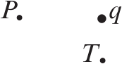
- An isolated positive charge q is in the plane of the page, as shown above. The directions of the electric field vectors at points P and T, which are also in the plane of the page, are given by which of the following?
Point P Point T
  - Left Right
  - Right Right
  - Left Toward the top of the page
  - Right Toward the top of the page
  - Left Toward the bottom of the page

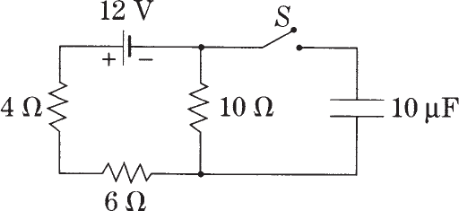
- What is the current in the 4 Ω resistor while the switch S is open?
  - 0A
  - 0.6 A
  - 1.2 A
  - 2.0 A
  - 3.0 A

